Lab 4: Designing the Controller of the CPU

CSEE 4280 – ADVANCED LOGIC DESIGN
SPRING 2018

Pre-Lab Due (30 points): Feb 2 Friday 1:30 pm

Report Due (70 points): Feb 8 Thursday 5 PM

Total Points: 100

Designing the Controller

We will design the complete controller for our CPU in this lab. Please start your design only after fully understanding the materials from the lecture. We will follow the recommended three steps in the lecture in order to design the controller.

Step 1: Design and Simulate the Controller FSM

- Please design the FSM corresponding to the controller of the CPU. We discussed the number of states and functions of each state in the class. It is time for you to design it based on the discussion and your understanding of it. This is a pre-lab component, you need to show the schematics of the FSM with states and transitions.

- Create and add CONTROL.v to your project. You need to convert your design into Verilog entry (text based design).
  - Inputs are: clk, clr, reset
  - Outputs are: s₀ s₁ s₂ s₃ s₄ s₅

- Once you have your CONTROL.v, you will need to test whether it works according to your design in a test bench. Please be exhaustive in your testbench. This is a critical part of the controller design. Very often students had to come back to this part because they did not examine their design thoroughly. Please do yourselves a favor and do a job here.

- We need to create a symbol out of the CONTROL.v you just designed. Please follow the instruction below.

- In Project Manager, Create Schematic Symbol from CONTROL.v (under Design Entry Utilities in the Process View box).
- Your symbol of control should look like the following. Left side are inputs, right side are outputs.
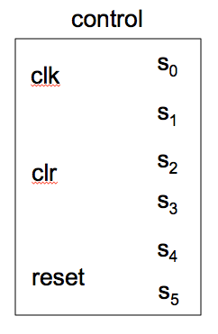

Step 2: Encoding Instructions

- Please encode the instructions of IR(7:0) from the instruction register. You are recommended to use the 1-hot encoding method. The following encoding scheme is also recommended.
ADD: 00000001
SUB: 00000010
CLEAR: 00000100
BNZ: 00001000
STORE: 00010000

Step 3: Determining the Control Signals

- This will be the most critical part of the lab. We need to agree on the overall design before proceeding to the schematics. Therefore this will be a pre-lab component that I will check in the next lab session.

- The control signals need to be decided based on the states, transitions, and the specific instructions to be executed. You are given a table in the lecture to decide the control signals. Please complete it and show it to the instructor before drawing the schematics.
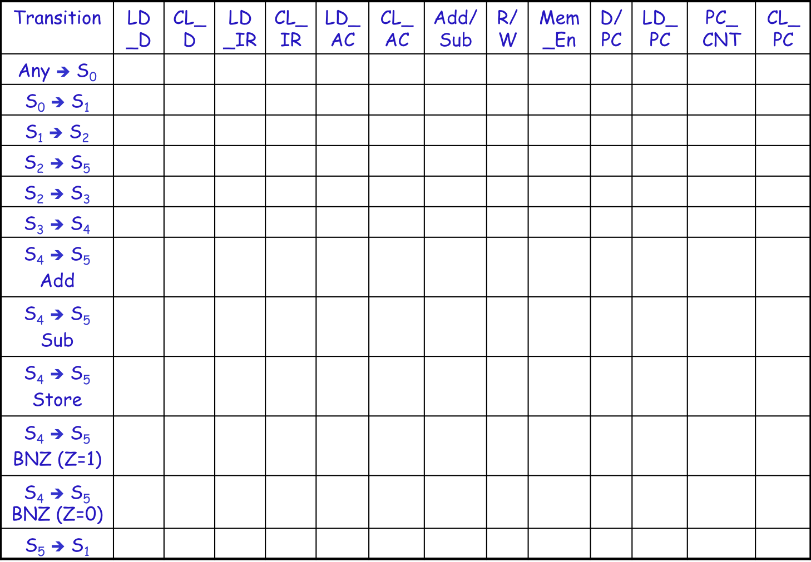

- Based on the above table, please list the Boolean functions of all control signals. They are: LD_D, CL_D, LD_IR, CL_IR, LD_AC, CL_AC, ADDSUB, RORW, DORPC, LD_PC, PC_CNT, CL_PC, MEM_EN.
- After checking with the instructor, you can start drawing the schematics of the controller based on your design. Create a New Source of type Schematic in the project. Name it controller_sch.sch. Place an instance of the symbol created in Step 1 on the schematic drawing sheet and draw the rest of the schematics. It is a little complicated so make sure to pay attention to its details.

  - Note: The three signals CL_IR, CL_D, and CL_PC are all equal to the RST signal. In the following schematic, they have been combined into the single CL signal, which will eventually be connected to all these three signals in the datapath.

  - Note: Double inverters will be used in the schematic to allow for the same wire to be connected to more than one port. For example, the RST signal is connected to an input port, but we also want to connect it to an output port that will provide the CL signal to the three reset signals of the registers PC, D, and IR. Therefore, we include 2 back-to-back inverters. If we did not employ the double inverters, ISE would report an error.

  - Your complete controller should look like the following. Left side are inputs, right side are outputs.
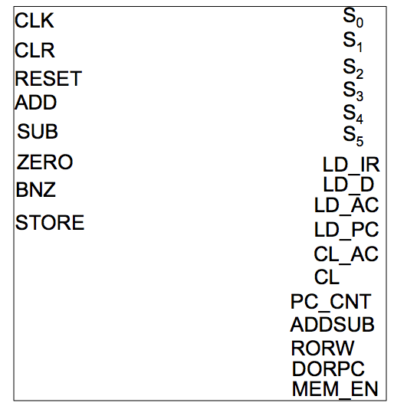
Controller schematic drawing
- Simulation of the complete controller.
  - From Project Manager create a test bench named controller_tb.v and associate it with controller_sch.sch.
  - With the aid of the test bench, simulate and verify your results. A test bench waveform and result are attached for your reference.

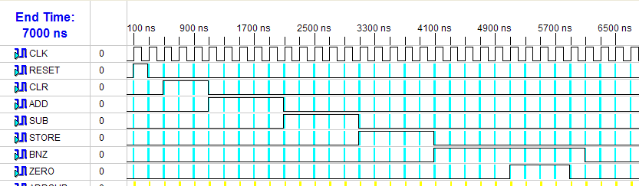
Test bench
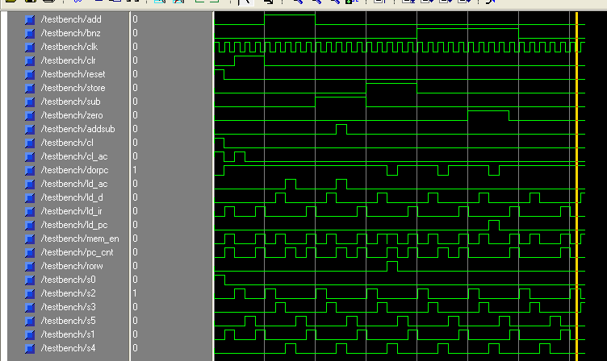
Simulation results

Lab Report/Code Requirements

Lab Report Format

Each team should submit one report using the format provided below. You should provide a detailed description/discussion for each lab report item including all schematics, codes and simulation waveforms from testbench. The lab report should be in WORD or PDF format and submitted as a single file to the dropbox in ELC. Please submit your lab reports in appropriate assignment folders on ELC before the deadline. 30% credit will be taken off if the submission is late by 0-24 hours. After 24 hours, late submission will not be accepted and zero credit will be given to the lab report.

1. Student Information (First page)

Lab Number and Title:
Names of members in the team:
E-mails:
Contributions: Please list contributions (in estimated percentages) of each member in the following categories.
- Pre-lab design and analysis
- In-lab module and testbench design
- In-lab testbench simulation and analysis
- In-lab FPGA synthesis and analysis
- Lab report writing

2. Lab Purpose (Second page)
Provide a brief summary of the lab assignment.

3. Implementation Details
Provide a detailed description of the steps you followed to implement the lab. Be sure to include all relevant information. Recommended information to be included:
- Pre-lab design and analysis
- Schematics of your design if available
- Module and testbench code

4. Experimental Results
Describe the results of the lab assignment. Be sure to include any simulation waveforms for testbench. You need to summarize the simulation results, supplemented by the evidence from Screen Captures of the waveforms. Please DO NOT just copy the waveforms as the results. You need explain why they correctly verify your design. When you attach the waveform screen captures, please crop them so that the variables names, time scale and waveforms are visible in your file.

5. Significance
What is the importance of the lab? How will you use the information you learned in this lab in the future?
In which applications you can use this information?

6. Comments/Suggestions
Please provide any comments or suggestions you may have for this lab assignment. Please indicate any areas of difficulty you encountered for this lab assignment.

7. Additional Lab Specific Information
Attach any additional information requested for this lab, including schematics, simulation waveforms, or manually performed tasks.
Grading Policy
Only one copy of the lab report from each team is needed. The grade for the report will apply to both team members, provided that each team member contributes roughly equally (50/50 – 40/60) to the lab. In the case where one team member contributes disproportionally lower to the lab, the instructor may reduce the grade of this member. Late submission after due date will receive partial credits (70% of credit for 0-24 hours late submission, no credit for more than 24 hours late submission).
Plagiarism: If plagiarism is found in reports, all of them will get ZERO points immediately, and face serious consequences.

